SVI Area Community Connections Challenge Overview  Objective of the challenge:  This challenge has our members working to try something new or take what you are already doing one step further to strengthen existing relationships and create opportunities for our members to become engaged with our larger non-Guiding community.  The challenge is organized into four categories, with ideas and activities for individuals, Units, Districts or Guiders working with girls to assist in easily making connections. Some of the activities are directed at adults and with a little modification can be completed by a Unit. | 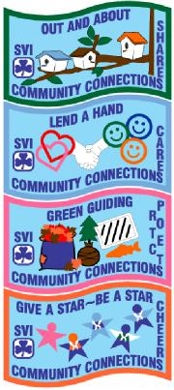
We have also included:

• where the challenges fits into old program levels
• unit passports for girls
• unit record sheet
SVI Area Community Connections Challenge
OUT AND ABOUT Connect to Share
Community Connections ... come see us now
Sharing in Celebrations... Sharing Unit Connections Stepping out
LEND A HAND Connect to Care
Community Service
GREEN GUIDING Connect to Protect
Environmental Service stewardship
GIVE A STAR – BE A STAR Connect to Cheer
Blowing Our Own Horn
Warm Fuzzies News Bites
Each Section has its own evaluation form.
Please complete the CREST ORDER form and the appropriate evaluation form for the section(s) completed with digital pictures if possible (ensure the members involved have a Yes on the IR.1 and that you have permission from non-Guiding persons) and return to:
Girl Guides of Canada, SVI Area. 611 Linnet Lane, Victoria, V9E 1B2 in an envelope, marked "SVI Community Connections Challenge" OR email svigirlguides@shaw.ca

