

**SVI AREA**

**COME STAY WITH US!**

SVI Area’s wonderful properties provide space for meetings, activities, sleepovers, a variety of camping experiences or a home-base for exploration on Southern Vancouver Island & the City of Victoria.

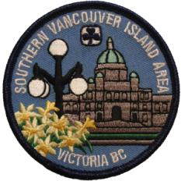

**SVI Area Guide House** in the City of Victoria; 15 minute walk to city centre.

**Bowker Hall** in the municipality of Oak Bay is a 10 minute drive east of the centre of Victoria.

**Kingswood Camp:**  Lodge or tenting on 28 acres near Elk/Beaver Lakes; 13km & a 20 minute drive from Victoria.

**Milnes Landing Camp:** Two cabins on 10 acres on the edge of the Sooke River; 40 km & 50 minutes from Victoria.

**Camp Jubilee:** Three large tent sites on a portion of 160 acres; salmon bearing creeks; 60 km/70 minutes from Victoria.

[www.svigirlguides.bc.ca](http://www.svigirlguides.bc.ca) ***2017 March. version***

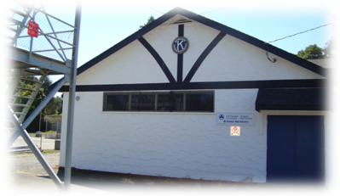

**BOWKER HALL**

1703 Monterey Ave, Victoria, BC

* Located in the municipality of Oak Bay behind the fire hall and police station.
* Next to park with playground.
* A great home-base to visit Greater Victoria which is 10 minutes away by car or city bus.
* Fully equipped kitchen
* Sleeps 24 (on floor) in large room on main floor
* Additional small room upstairs.
* Free parking
* Close to Oak Bay Recreation Centre (with pool, showers and more) & several other parks in neighbourhood
* Grocery Store 4 blocks away

**TO BOOK**: email [sviareacampbookings@gmail.com](mailto:sviareacampbookings@gmail.com)

**Brochure at**: <http://www.svigirlguides.bc.ca/camps/Bowker%20Hall%20Brochure.pdf>

*************************************

For information on travel to Victoria from mainland BC, contact:

* BC Ferries: <http://www.bcferries.com/>
* Pacific Coach Lines: <http://www.pacificcoach.com/>
* Local BC Transit for city bus from Swartz Bay Ferry: 250-382-6161 or <http://www.transitbc.com/regions/vic/>

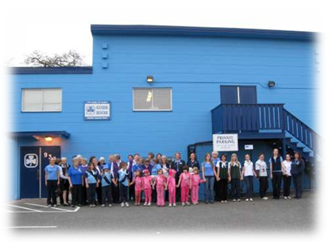

**SVI AREA GUIDE HOUSE**

938 Mason St, Victoria, BC

Southern Vancouver Island Guide House is centrally located near downtown Victoria, BC

* Easy access to grocery stores, city bus stops and many tourist attractions.
* Two story building with elevator is wheelchair accessible
* Large main room (sleep on floor)
* Full kitchen facilities (stove, microwave, fridge, small appliances, cooking utensils & dishes/cutlery)
* Bathrooms with shower
* Free on-site parking
* Reasonable rates
* Accommodates 30 people overnight
* 24-hour security patrols

**TO BOOK: call SVI Area Office at**

**250-383-1712 (may leave message) or email** [svigirlguides@shaw.ca](mailto:svigirlguides@shaw.ca)

**Brochure at:** <http://www.svigirlguides.bc.ca/camps/Guide%20House%20Brochure%202010.pdf>

**KINGSWOOD CAMP**

611 Linnet Lane, Saanich, BC

* 28 acres; borders Elk/Beaver Lake Park; A locked camp gate accesses park trail.
* Lodge & tenting sites available.
* Canvas tents and patrol boxes (pots/utensils) available to use for free.
* GGC canoes & PFD’s are stored at camp & may be rented separately (must book before arriving at camp).
* Quaint Chapel with log benches on rock outcrop available for all campers to use.
* Hiking trails & swimming nearby.
* Caretakers live on site.

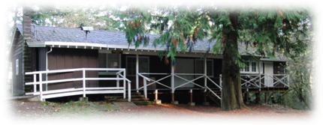

**McKevitt Lodge** has kitchen, bathroom (no shower), large activity room and bunkroom with 24 plywood bunks/no mattresses. It is wheelchair accessible. Max. overnight capacity is 30 campers. **Two tenting sites** have dining shelters (with wood stove), potable water, fire pits and outhouses. Maximum capacity of each site is 30 overnight campers.

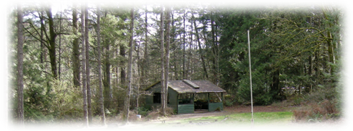

**CAMP JUBILEE**

9548 West Coast Road, Shirley, BC

* 160 acres of primarily undeveloped forest with two salmon-bearing creeks.
* 10 acres developed for camp use.
* No power; landline phone available; very erratic cell phone coverage.
* 25 minutes to grocery stores in Sooke.
* Three tenting sites each have dining shelters with woodstoves, outhouses, fire pits and storage buildings.
* Potable water available in tank on site.
* Canvas ridgepole tents and patrol boxes (cooking pots/utensils) available to use for free. *Infrequent shy bears*
* Maximum capacity: 40 campers per site.

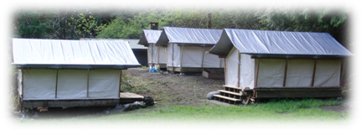

**Kirby Site** has four vitex platform tents accommodating 4-6 campers each. Pitch extra tents in small field if required.

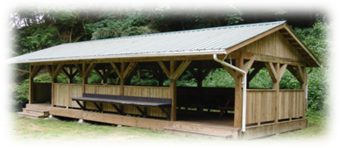

**Bridges Site** has two large dining shelters. Campers pitch tents in large field.

**Gateway Site** is very close to parking lot and dining shelter is small.

**MILNES LANDING CAMP**

2292 Sooke River Road, Sooke, BC

* 10 acres located on the Sooke River minutes from downtown Sooke
* Groceries, gas and other items nearby
* SEAPARC indoor pool & (small) Sooke Museum within walking distance.
* Two cabins each provide sleeping space, kitchen, bathroom with flush toilets & sinks, activity areas and outdoor fire-pits.

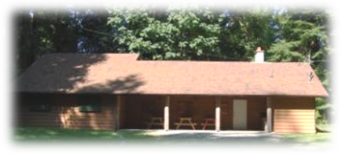

**Upper Cabin** is situated in a forested area. Bunkroom has 24 plywood bunks/no mattresses. It is wheelchair accessible. One shower stall is available. The cabin accommodates maximum 30 campers.

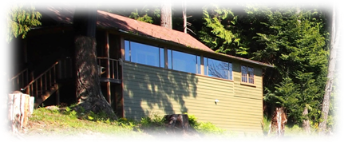

**Lower Cabin**,built in 1938, overlooks the river estuary from a closed-in dining veranda. 20 triple-decker hammock style bunks hang from the ceiling. The cabin accommodates 24 overnight campers.

To book a camp email [sviareacampbookings@gmail.com](mailto:sviareacampbookings@gmail.com) . Additional information & rates available at <http://www.svigirlguides.bc.ca/camping.htm>